Executive Headteacher - Collette Hunnisett
11 January 2022

Dear parent/carer

Staff Training Day – Friday 11 February 2022

I am writing to inform you that the academy will be closed for students on Friday 11 February 2022 for staff training.

Your child will be expected to return to the academy following the half term break on Monday 21 February 2022, as per his/her timetable.

If you have any questions, please do not hesitate to contact the academy office on 01708 853781.

With thanks and kind regards

Yours sincerely

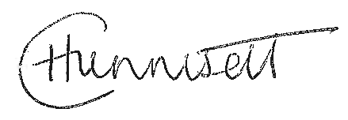

Collette Hunnisett
Executive Headteacher

